BSA-150 BSA-1000
150W / 1000W Surge (Lightning ) Arrester

Installation Instructions

For maximum protection keep the earth lead length as short as possible .The earth lead must be connected to the mounting flange hole of the arrester and then to a 1500mm copper coated earth stake or similar.

Note: The lightning arrester is bi-directional. The antenna connection can go on either end.

This unit is not weatherproof and must be sealed against moisture.

CAUTION

WHEN INSERTING MALE UHF CONNECTOR , CENTRE PIN INTO CONNECTOR, DO NOT ALLOW ANY ROTATION.

IT IS VERY IMPORTANT THIS UNIT BE GROUNDED TO A LOW IMPEDANCE (LOW R AND LOW L) GROUND SYSTEM IN ORDER TO WORK PROPERLY.

DO NOT CONNECT WHEN A STORM IS NEAR.

DO NOT CONNECT WHEN TRANSMISSIONS ARE OCCURRING.

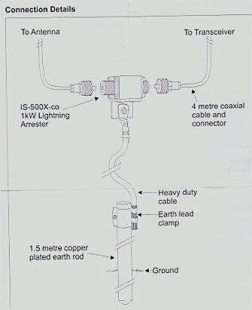
DO NOT BE AROUND OPERATING EQUIPMENT IN AN ELECTRICAL STORM.
THE SURGE SUPPRESSOR MAY SAVE YOUR EQUIPMENT FROM DANGER, BUT SHOULD NOT BE CONSIDERED AS BEING SAFE FOR PRESENT PERSONNEL.
BSA-150 / BSA-1000 lightning arrester

